**Metamask and Insula:**

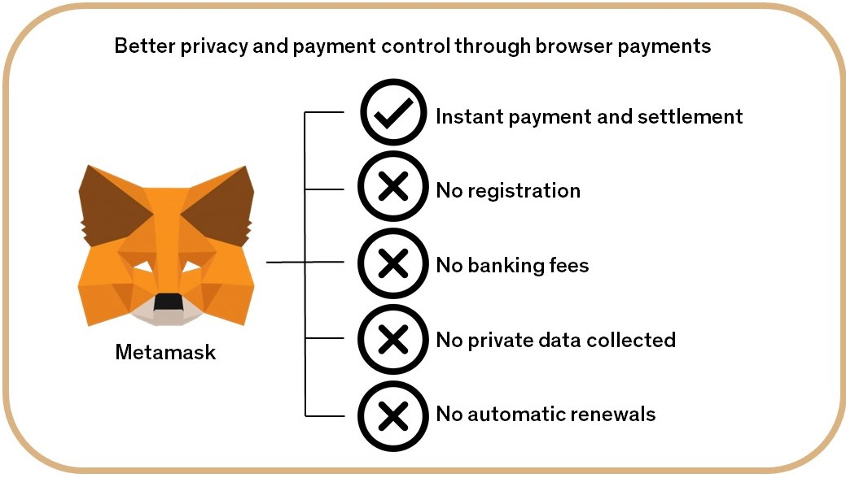

If you have an interest in cryptocurrencies, your must-have item is a cryptocurrency wallet. For those targeting [Ethereum](https://icoholder.com/blog/best-ethereum-exchange/) and ERC-20 tokens, one of the top options is MetaMask.

[MataMask](https://metamask.io/) is an online crypto wallet.

The wallet has become a favorite for crypto enthusiasts because it does not simply store the digital coins, but further allows users to interact with Insula [smart contracts](https://www.bitdegree.org/tutorials/what-is-a-smart-contract/) and [decentralized applications (DApps)](https://www.coindesk.com/information/what-is-a-decentralized-application-dapp/).

In order to be able to connect to Insula applications you need a Metamask Wallet installed.

In order to be able to invest in Insula applications you need a Metamask Wallet installed with a positive Ethereum (ETH balance).

What can you do with Metamask:

**a-*Buy, store and send Insula tokens globally:***

Available as a browser extension and as a mobile app, MetaMask equips you with a key vault, secure login, and token wallet—everything you need to manage your Insula digital assets.

Metamask allows you to custody your own assets by storing your private keys yourself rather than relying on a centralized intermediary.

***b-Explore Insula blockchain apps:***

## MetaMask provides the simplest yet most secure way to connect to Insula’s blockchain-based applications. You are always in control when interacting on the new decentralized web.

## ***c-Own your investor data:***

MetaMask generates passwords and keys on your device, so only you have access to your Insula accounts and data. You always choose what to share and what to keep private.